SQLA1 Assignment  
  
* To create the first table SALES_REP, I highlighted the create table code line and then pressed execute. Background pattern

  Description automatically generated with low confidence
* The table now shows up in my database

* To insert the data into the table I highlighted the data and then pressed execute. 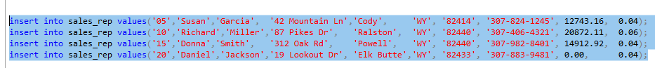
* This is the design of the SALES_REP table. Graphical user interface, table, Excel

  Description automatically generated  
  - This is the data in the table. Graphical user interface, application

  Description automatically generated
* I used these to SQL statements.  
  select * from SALES_REP;

exec sp_columns SALES_REP;

* I then repeated this for the next four tables, and I finished with this.  
  Table

  Description automatically generated
* This is the customer table.

* This is the Invoice Line table.

This is the Invoices table.

* Lastly this is the Item table.

These are the SQL statements I used.  
